**Steps to Change Gateway configuration**

Step1. Navigate to release tags SVN location.

<http://svn.incomm.com/svn/fs/GatewayIntegrationServices/FinancialServices/tags/FSAPI_GPP_REL_VERx.x/TIBCO>

For eg: (release 4.3)

<http://svn.incomm.com/svn/fs/GatewayIntegrationServices/FinancialServices/tags/FSAPI_GPP_REL_VER4.3/TIBCO>

Step2. Navigate to the below location in QA Gateway server (For eg: 10.4.121.66) : “/app/data/TIBCO_HOME/tibco/cfgmgmt/asg”

Step3. Move the latest FinancialServices directory from SVN to the above mentioned path (replace existing FinancialServices – if any) .

(for eg: Moving SVN code to QA gateway server as depicted below )

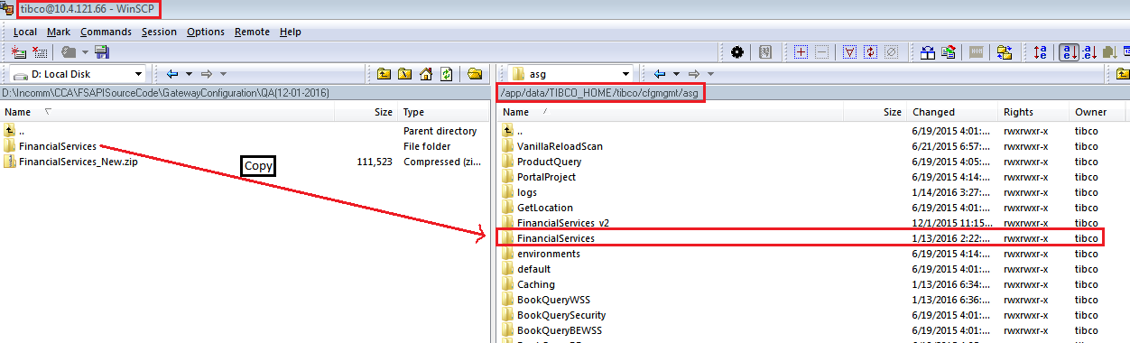

Step4: Start the Gateway service with the below command. (Restart by killing existing service – if any)

1. Navigate to “/opt/tibco/asg/2.1/bin” (QA: 10.4.121.66)
2. ps -ef|grep asg
3. kill running asg engine for FinancialServices gateway application that is running with “./asg-engine -u asg-caching-core -p /home/tibco/TIBCO_HOME/tibco/cfgmgmt/asg/asgFS.properties -a FinancialServices” parameter.



1. kill -9 pid (25107 is a sample pid)
2. Start the application using the command

“nohup ./asg-engine -u asg-caching-core -p /home/tibco/TIBCO_HOME/tibco/cfgmgmt/asg/asgFS.properties -a FinancialServices 2>&1 &”

1. Monitor the log file for graceful startup of the service.

tail -1000f nohup.out